# 3. ReactJS-HOL

Code:

CalculateScore.js

import React from 'react';

import '../Stylesheets/mystyle.css';

function CalculateScore(props) {

const average = props.total / props.goal;

return (

<div className="score">

<h2>Score Calculator</h2>

<p>Name: {props.name}</p>

<p>School: {props.school}</p>

<p>Total Marks: {props.total}</p>

<p>Goal: {props.goal}</p>

<p>Average Score: {average}</p>

</div>

);

}

export default CalculateScore;

mystyle.css

.score {

width: 400px;

margin: 40px auto;

padding: 20px;

border: 2px solid #000;

border-radius: 10px;

background-color: #f2f2f2;

font-family: Arial, sans-serif;

color: #333;

}

App.js

import React from 'react';

import CalculateScore from './Components/CalculateScore';

function App() {

return (

<div>

<CalculateScore name="Harsh" school="DPS" total={450} goal={5} />

</div>

);

}

export default App;

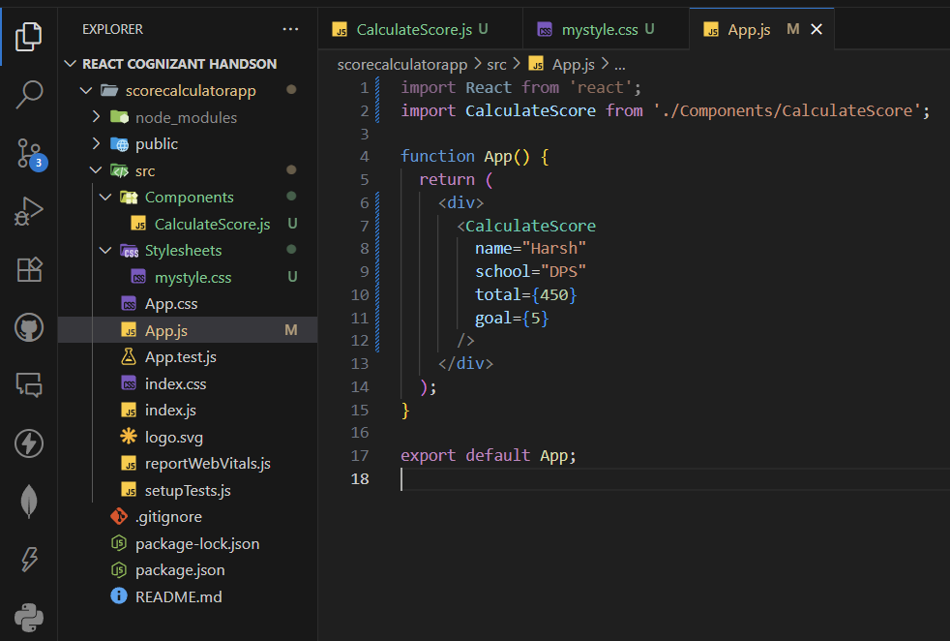File Structure:

Output:

